INTRODUCTION:
In this module, basic concepts of simple oscillator are explained. Initially, an example of simple pendulum is taken and the basic terminology i.e., what is initial displacement, initial velocity,natural frequency and time period are explained. Each of these terms is illustrated by giving an example, where user can enter his value and observe the behavior of structure for his input.
Simple harmonic oscillator consists of a mass (m) hanging from a string of length (l), fixed at a pivot point P. When the mass is displaced from its mean position by giving some initial displacement (angle), oscillator starts swinging back and forth with periodic motion.
THEORY:
By applying Newton's second law for rotational systems, the equation of motion for the pendulum may be obtained.
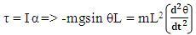
Where, τ = Torque ; I = Moment of Inertia; α = Angular Velocity. m is mass of the oscillator, l is the length of the oscillator and theta is initial displacement. The above equation can be rearranged as -
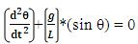
If the amplitude of angular displacement is small then we can use the approximation (sinθ ≈ θ). By considering the above approximation, the equation of motion reduces to :
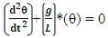
The solution for equation of simple harmonic oscillator is
where, θ(t) is the history of oscillation, θ0 is the initial angle, ω=(g/l)1/2
OBJECTIVE:
Objective of simple harmonic oscillator experiment is to understand the concept of time period (natural frequency) in harmonic oscillations .
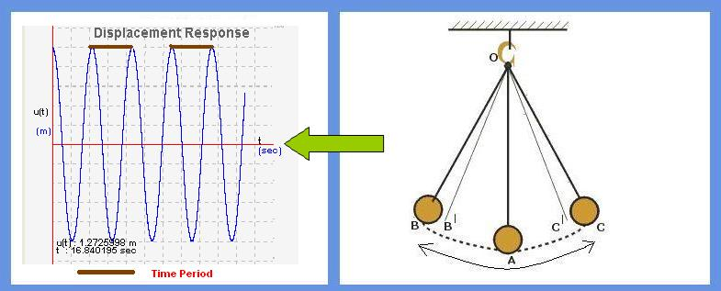
MANUAL:
Start the experiment with the default values of length, mass and initial displacement (in angle). Pause the experiment after few cycles and note the observation.

Observation 1:
1. Find the time period of the pendulum by noting the time interval of any one complete
cycle from the response graph.
2. You may note that this time period value is same for any complete cycle.

Observation 2:
1. Repeat the above procedure by changing the initiatime period.
2. You may observe that the time period value does not change with initial displacement or even changing the mass of the oscillator. It means Time Period is independent of mass of the oscillator and also independent of initial displacement.

Observation 3:
1. Keeping the mass and initial displacement as default values, repeat the experiment by changing the length.
2. Make note of the time interval of any one complete cycle from the response graph. You can observe that the Time Period of the simple harmonic oscillator is dependent on the length of the oscillator.
3. Repeat the experiment by giving different lengths of oscillator and draw the graph between length and time period of the simple harmonic oscillator.

PART - 2
ANIMATION STEPS
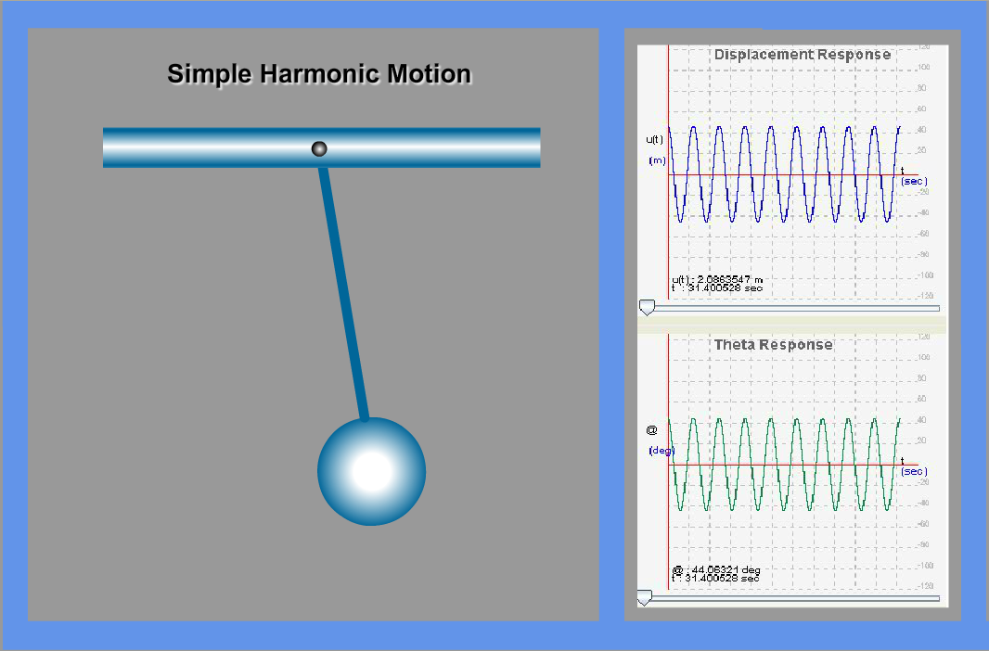

PART – 3
VIRTUAL LAB FRAME
